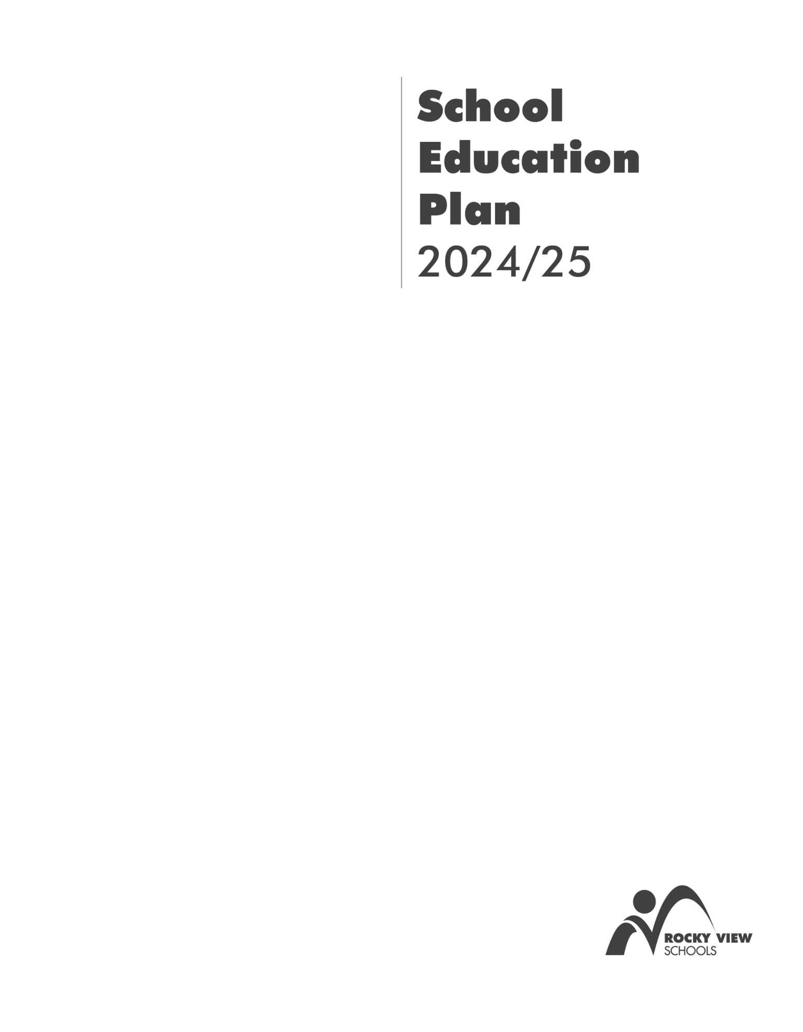

Springbank Middle School

April 2025

# Table of Contents

Administrators’ Message 4

School Profile 5

Student Feedback from Spring 2024 6

Parent Feedback from Spring 2024 7

RVS Assurance Results 8

OurSCHOOL Results 9

Alberta Education Assurance Measure Results 10

Advancing students numeracy and literacy skills 11

Building future-ready students 13

Creating inclusive, engaging, healthy learning opportunities for all students 15

School Council Review 17

# Administrators’ Message

As we embark on the 2024-25 school year at Springbank Middle School (SMS), we are excited to share our plan that continues to foster a vibrant learning environment for all our students. Our goals are designed to enhance student experiences and growth that align with Rocky View Schools, *Focus on the Future, and* we invite our SMS families and community to engage in this journey with us.

At SMS, we continue to be committed in promoting student literacy through a variety of strategies. We will refine and implement effective teaching methods that enhance reading fluency, expand vocabulary, and improve comprehension across all subjects. By integrating diverse reading materials and interactive practices, we aim to make reading a rewarding and enjoyable adventure for every student.

We also believe in the power of hands-on experiences to promote student competencies and personal growth. Through engaging projects and activities, students will have opportunities to reflect on their current skills and envision their future contributions to society. By making explicit connections to careers and essential skills, we aim to deepen their understanding of competency development. This practical approach will challenge and inspire them to think critically about their roles in our community.

SMS values the rich diversity within our school. We will continue to implement strategies that encourage students to engage with and appreciate the unique backgrounds and perspectives of their peers. By fostering an inclusive atmosphere with clear school-wide expectations, we hope to create a sense of belonging where every student feels valued.

Together, let’s make this year one filled with learning, growth, and celebration of our diverse community.

Thank you for your continued support and partnership in fostering our students’ potential.

Glen Brooker Diana Stapor

Principal, Springbank Middle Assistant Principal, Springbank Middle

# School Profile

|  |  |
| --- | --- |
| **Principal:** Glen Brooker  **Assistant Principal(s):** Diana Stapor  **Website:** <https://springbankmd.rockyview.ab.ca> | **Mission:**  At Springbank Middle School, we create a nurturing engaging environment that prepares and inspires learners to be contributing citizens of the 21st century global community.  « À l’école Springbank Middle, nous créons un environnement stimulant et engageant qui prépare et inspire les apprenants à devenir des citoyens à part entière de la communauté mondiale du 21e siècle. »  **Vision/Purpose/Beliefs:**  Springbank Middle School has embarked on a journey with students, staff, and the community to rediscover our mission, vision and purpose. We will continue to focus on fostering an inclusive and healthy learning environment where every student and staff member thrives and center our purpose on building **genuine connections**, create a **s**trong **sense of belonging**, provide **opportunities for growth,** and nurture **energy for success** in a **collaborative community** of learners. |

**Total Number of Students:** 553

**Grades Served: 5-8**

**Total Number of:**

* Classroom Teachers: 23
* Learning Support Teacher(s): 2
* Learning Assistant(s): 5
* CDA(s)/Guidance Counsellor(s): 1
* Learning Commons Facilitator(s): 1
* Office staff: 2
* Caretaking staff: 4

## School Diversity Profile

As with all Rocky View Schools, Springbank Middle School reflects a rich and diverse learning community.

Notably, 2% of our students self-identify as Indigenous students.

English as an Additional Language learners represent 6% of our school population. The most common first languages for these students are Japanese, Arabic, Chinese, Mandarin, and Cantonese.

As an inclusive school, we welcome 2% of our students who have significant learning needs.

Additionally, our school offers:

* Dual-track French Immersion programming for all students from grade 5-8.
* Global Academy which provides enhanced golf and hockey skills development throughout the year.
* Two cohorted outdoor leadership classes focussing on naturalistic and experiential learning with an Indigenous framework.
* We provide all middle school level school sports within Rocky View School Division.
* Student-driven clubs including: Drama, House Team Captain Leadership team, Intramurals, Soccer Club, VR club, and Board Games club.
* C.A.R.E. awards: a long-running tradition recognizing students who follow values according to community, accountability, resilience, and empathy.

# Student Feedback from Spring 2024

|  |
| --- |
| **What do students think are some things that are going well?**   * Students are motivated and strive to do well in school as driven by parents and teachers’ expectations * Students are academically to pursue post-secondary opportunities primarily directed at college or university programs |
| **What do students think could be worked on or improved?**   * More student learning opportunities which engage and create meaningful experiences to increase motivation and interest * Students feel they have a mixed and vague understanding of their own culture and other cultures * Students feel the education quality is low in comparison to what teachers and parents feel * Student understanding of citizenship as it pertains to global and cultural citizenship and how they can positively impact their school and great communities * There could be improved school climate and positive relationships between staff and students |

# Parent Feedback from Spring 2024

|  |
| --- |
| **What do parents think are some things that are going well?**   * Parents are actively engaged in their student learning and the school community * Parents feel their students are experiencing success due to a high quality of education * Learning support access has improved significantly over the course of the last couple of years to support student learning |
| **What do parents think could be worked on or improved?**   * Student understanding of the definition of citizenship and how it impacts their community * Continue to improve access to learning support resources to enhance student learning * Parents would like to see more connection to relevant careers which are responsive to community culture |

RVS Assurance Results

|  |  |  |
| --- | --- | --- |
|  | **Data Source** | **Most Recent Results** |
| **EICS Math Assessment grades 5-8** | EICS Math Assessment 2024 | 79% |
| **Percentage of French Immersion students reading at or above grade level on the Groupe Beauchemin+ (GB+) Grade 5 & 6.** | Groupe Beauchemin+ | 57% |
| **Percentage of students reading at or above grade level on the Benchmark Assessment System (BAS) Grade 5 – 6.** | BAS | 96% |
| **Percentage of students meeting expected grade level outcomes on the RVS writing assessment Grade 7.** | RVS Writing Assessment | 58% |
| **School-wide score on Positive Behavioural Intervention and Supports (PBIS) Tiered Fidelity Inventory.** | Tiered fidelity inventory by PBIS specialist | 27% |
| **Percentage of students who are absent less than 10 per cent during the school year.** | PowerSchool | 87.5% |
| **Percentage of students with Individual Program Plans who are achieving their learning goals.** | Dossier Data | 100% |

|  |
| --- |
| **What does this data tell us is going well?**   * Students who are accessing learning supports are experiencing success. * The great majority of our students are regular attenders. |
| **What does this data tell us could be improved or worked on?**   * There is a need to integrate PBIS into school community culture and routines to enhance safe, respectful, and caring learning environments. * A need to focus heavily on French Immersion supports to improve literacy skills. * Continue to integrate literacy support across all discipline areas. * Continue to support students with writing to enhance their ability to meet grade level expectations. |

# OurSCHOOL Results

|  |  |
| --- | --- |
|  | **Results as of Spring 2024** |
| **The percentage of students who are interested and motivated, trying hard to succeed and feel challenged and confident in their learning related skills.** | 63% |
| **The percentage of students who value school outcomes and have positive homework and studying behaviors.** | 61% |
| **The average score for relevance, rigor and effective learning time.** | 6.6 |
| **The percentage of students who report a sense of purpose in life, who devote time to pleasurable activities, who have an understanding of their own and other cultures, and who have positive health and are goal oriented.** | 77% |
| **The percentage of students planning to finish high school and pursue a trade, apprenticeship, college or university program.** | 54% |
| **The average score for positive teacher-student relationships, positive learning climate, and expectations for success.** | 6.8 |
| **The percentage of students who report they are able to control their emotions and behaviors and maintain focus on a task.** | 71% |

|  |
| --- |
| **What does our data indicate is going well?**   * Students put a lot of effort into their schoolwork and recognize the expectations for their success * Many students felt their learning matched their confidence level and challenged them in their coursework * Students exhibit both positive socio-emotional well-being with regards to their sense of purpose and overall happiness |
| **What does our data tell us could be improved on?**   * Students in grades 5 & 6 show to have higher positive homework behaviours in relation to grade 7 & 8 students * Although students are putting effort into their schoolwork, they are not seeing the relevance * Students feel they do not have a greater sense of understanding to cultures around them |

# A table with numbers and text Description automatically generatedAlberta Education Assurance Measure Results

Results are based on 20 parents completing the survey.

|  |
| --- |
| **What does our data indicate is going well?**   * Student learning engagement has improved over the last three years according to student, teacher, and parent responses * Students, parents, and teachers identify that education quality is strong in comparison to the provincial average * The school environment is indicative of a welcoming, caring, respectful, and safe learning environment * Parental involvement is very high to help support the learners in the school community |
| **What does our data tell us could be improved on?**   * Students understanding the definition of citizenship and how it plays a part within the school and greater community * Access to supports and services to help student learning to be comparable to the province |

# Advancing students numeracy and literacy skills

## Outcome: Students are numerate and literate.

## Outcome: Students are actively engaged in meaningful and relevant learning.

## How Might We: Offer a variety of reading strategies for students to increase vocabulary competency across all disciplines.

|  |  |  |
| --- | --- | --- |
| **School Goal 1:** Increase comprehension skills by 10% for all students across all core subject areas as measured by running records. | | |
| **Data that informed this goal:**  PAT Results:   * Science 6 – 70% * Social Studies 6 – 65% * French Language Arts 6 – 59%   GB+ data: 57%  F&P data: 96% | | |
| **Connection to the practice guide(s):**  Circular learning – learning is an iterative process that occurs in a circular manner rather a linear fashion. Learning should come back to what has been taught/learned. working with, reflecting on and returning to learning outcomes helps students make connections to the purpose of learning and reminds them that everything is connected (Instruction and Assessment Practice, pg. 7)  Collaborating – work collaboratively to build a thorough understanding on the use of classroom and school profiles to effectively allocate resources, and identify effective instructional practices and assessments based on current strengths, talents and needs of students in each class and the overall learning community. (Inclusion Practice Guide, pg. 16)  We believe that all members of our learning organization need to be learners in order for us to have the greatest impact on our students’ learning. The jurisdiction believes that all members of RVS have a critical role and responsibility in the determination of both individual and collective growth. (Professional Learning Practice Guide, pg. 6) | | |
| **Strategies:**   * Continue to refine and implement teacher methods of teaching reading for fluency, vocabulary, and comprehension. * Implement meaningful literacy-focused learning (develop a scope and sequence). * Integrate opportunities to provide access to explicit learning of targeted literacy skills in each grade level to be defined with teachers. * Offer learning specialist review to provide professional learning and reiteration of explicit reading strategies (fluency, vocabulary, and comprehension). * Teachers provide explicit targeted reading instruction around areas of challenge identified through standard assessments, such as PATs, in class assessment, and observation across all disciplines. * Create and utilize a literacy inventory of strategies to be utilized across all grade levels to provide consistency to enhance reading skills. | | |
| **Measures:**   * Improvement on F&P comprehension scores * Improvements on GB+ for French Immersion comprehension scores * Grade 6 PAT results (ELA, FLA, Science, Math, Social Studies, Études Sociales) | | |
| **Parents can:**   * Encourage their students to read at home * Check PowerSchool regularly * Engage their child in conversation about their learning | | |
| **Check-Ins** | **Progress and Analysis** | **Adjustments to Plan** |
| **December 6** | * Developed a scope and sequence for EFT with teachers and areas of need for students. Google Classroom has been set up for teachers to access meaningful and explicit teaching of literacy. * Class reviews have been completed for all students and to support student learning needs. * French Immersion Summit (November 1st) Professional learning discussion to determine areas of growth and improvement for the French Immersion students resulting in a French Immersion Soiree (hosted on December 4th) | * Ongoing EFT development, refinement and integration with students to see growth in comprehension * Enhance parent involvement within discussions about French Immersion programming to support students from home. Create a parent focus group. |
| **April 4** | * Continue with EFT literacy focus; include connections to numeracy, digital, and career exploration to enhance literacy * Teacher inquiry into literacy strategies to enhance student understanding of various content areas including other core subjects * Specific literacy resources are made accessible (Raz Kids, Infos-Ados, etc.) for French Immersion students to improve fluency, vocabulary, and comprehension | * Check-in with teachers to gauge how literacy-focused lesson plans are embedded * Teachers reflecting on which specific literacy tasks and activities support student literacy in their classrooms * Continue to reinforce literacy strategies across all subject areas * FI home reading program set-up to improve |

# Building future-ready students

## Outcome: Students demonstrate strong abilities in critical thinking, communication, problem solving, collaboration, managing information, cultural and global citizenship, creativity and innovation, and personal growth and well-being (Alberta Education student competencies).

## Outcome: Students graduate high school prepared to be successful for any path they choose.

## How Might We: Help students understand key competency skills by linking them to the curriculum, career opportunities, and experiences that encourage them to think about how they contribute to society now and in the future.

|  |  |  |
| --- | --- | --- |
| **School Goal 1:** By June 2025, improve all students' understanding of competencies as measured by OURSCHOOL survey questions. | | |
| **Data that informed this goal:**  OurSCHOOL Survey results:   * + Intellectual engagement composite (Grade 7 & 8) – 54%   + Interest and motivation (Grade 5 & 6) – 69%; (Grade 7 & 8) – 28%   + Relevance – 62% (Score rating of 6.2)   AEA Survey Results:  The percentage of teachers, parents and students who agree that students are engaged in their learning at school.   * Parents – 97% * Teachers – 100% * Students – 69%   Current and former student feedback, parent council feedback | | |
| **Connection to the practice guide(s):**  Design differentiated instruction to intentionally make learning engaging, meaningful, and effective for all students (Inclusive Education Practice Guide, pg. 13)  Authentic tasks - Connecting learning to real life experiences makes learning meaningful. Using authentic, hands-on experiences supports the transfer of learning so students can take what they have learned and apply it to solve a real-world problem. (Instruction and Assessment Practice Guide, pg. 7)  It is the responsibility of staff to build relationships with each student to understand them as learners, including knowing and understanding their interests, skills, and abilities (Instruction & Assessment Practice Guide, pg. 4) | | |
| **Strategies:**   * Teachers explicitly teaching highlighting classroom activities that pertain to specific competencies. * Explicitly teach Alberta Education Competencies within EFT (Extra Flexible Time) blocks to promote student understanding and skill development in these domains. * Visually represent and present competencies in classrooms/halls (ex: posters, etc.) | | |
| **Measures:**   * OurSCHOOL Data – construct question(s) directed at competency understanding * AEA Survey results * Parent council feedback * Student feedback and reflections | | |
| **Parents can:**   * Engage in career connection opportunities by participating in field trips, coming in as guest speakers. * Attend Parent Council meetings. | | |
| **Check-Ins** | **Progress and Analysis** | **Adjustments to Plan** |
| **December 6** | * Continue to work on getting guest speakers to come in and share connections with competencies and future opportunities within diverse career fields. * Continued development of EFT blocks to be utilized to teach Alberta competencies. * Competencies posters were shared with teachers to utilize in class. | * Make competencies visible throughout the school. * Continue to develop lessons for explicit teaching of competencies. |
| **April 4** | * Incorporation of French Immersion field trips to allow students to view and connect applications for French in the community * Students working on inquiry projects based on interest and exploration in various subject areas * Classwork in EFT to describe how competencies are used in different subject areas (ex: Science – collaboration & communication) | * Continue to make competencies visible throughout the school and competency-targeted activities * Possible attachment of competency work in EFT in the future |

# Creating inclusive, engaging, healthy learning opportunities for all students

## Outcome: Students are happy, healthy, feel they belong and are safe, and experience success in learning environments that are inclusive of every learner and celebrate diversity.

## Outcome: Students are self-aware, focused and demonstrate perseverance and resilience.

## How Might We: Apply strategies to facilitate students' active engagement in recognizing and celebrating diversity within our school community.

|  |  |  |
| --- | --- | --- |
| **School Goal 1:** By June 2025, our tier-wide fidelity inventory will be at 70%. | | |
| **Data that informed this goal:**  Tiered Fidelity Inventory (PBIS measure): 27%   * + Teams – 25%   + Implementation – 39%   + Evaluation – 0%   OurSCHOOL Data:   * + Positive Learning Climate – 61% (Score of 6.1)   + Students who possess understanding of their own culture – 43%   + Students who possess understanding of other cultures – 67%   AEA Survey:  Percentage of teachers, parents and students who are satisfied that students model the characteristics of active citizenship.   * Parents – 71% * Teachers – 72% * Students – 84% | | |
| **Connection to the practice guide(s):**  Positive and meaningful relationships are foundational to our success and therefore strive to leverage the diverse strengths, talents, and passion of our collective whole in fostering learning communities where all students feel they belong and see themselves meaningfully represented within their learning, their school, and their communities (Inclusive Education Practice Guide, pg. 4)  School cultures, where children and youth learn to feel safe, to belong, to understand and respect each other deeply and to celebrate and support rather than fear differences, are powerful constructs that can foster the social and mental well-being, and academic success of all students (Inclusive Education Practice Guide, pg. 6)  Community engagement – parents, school councils, students, community members, businesses, industry, and post-secondary institutions are partners in supporting implementation (Professional Learning Guide, pg. 7)  Every individual must continue to pursue growth and excellence through an engaged and empowered reflective learning journey (Professional Learning Guide, pg. 5) | | |
| **Strategies:**   * Create and refine purpose and vision for the school involving key stakeholders to support a sense of belonging for all school community members. * Design a school wide matrix for PBIS (Positive Behavior Intervention & Supports) school wide expectations. * Develop a consistent team to support PBIS initiatives. * Meaningful and explicit teaching of school wide expectations to support positive climate. * Invite guest speakers which reflect diversity and inclusion and provide meaningful instruction through a lens of empathy and understanding. * Establish teacher-driven committee for diversity responsible for developing school-wide events to support meaningful engagement in diversity. | | |
| **Measures:**   * OurSCHOOL survey results for:   + Positive Learning Climate, Students who possess understanding of their own culture   + Students who possess understanding of other cultures * AEA Survey Results – active citizenship * PBIS tiered fidelity results | | |
| **Parents can:**   * Participate in the development of Springbank Middle School’s new Purpose and Mission. * Parents can participate in and/or lead diversity opportunities. * Reinforce school wide expectations. * <https://www.pbis.org/pbis/what-is-pbis> | | |
| **Check-Ins** | **Progress and Analysis** | **Adjustments to Plan** |
| **December 6** | * Developed a purpose and vision with staff to be shared with students and families to be reflective of school wide expectations. * Surveying students and teachers on how they view school wide behaviors to gather data for future development of matrix. * Working on developing a PBIS matrix with staff team reflective of vision and areas of need to support safe and caring learning environments. | * Purpose and vision to be shared with students and families in January. * Feedback from students and staff to be reviewed and analyzed for matrix development purposes on December 11th. |
| **April 4** | * Developed PBIS matrix which was shared with staff, parents, and students * Ongoing PBIS meetings to refine school wide and classroom expectations. * School-wide assemblies and classroom visits to explicitly teach out expectations of being ‘Safe, Respectful, and Responsible’ * Ensuring explicit language around safe, respectful, and responsible are used when working with students on school wide and classroom expectations. | * Integrate regular and positive reinforcement of PBIS school wide expectations * PBIS Tiered Fidelity Inventory to take place on May 14th |

# School Council Review

**Presentation of School Education Plan**

|  |
| --- |
| **School council comments:** |

*Signatures indicate agreement with the plan*

**School Council Chair signature on behalf of the parents and community of School**

**Principal signature on behalf of students and teachers of School**