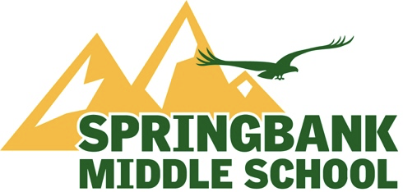

Springbank Middle School (SMS)
September School Council Meeting
7:00 P.M., Wednesday, September 13th, 2023

Zoom link:
Available on SMS Website

A G E N D A
- Welcome

  - Call Meeting to Order
  - Approval of Agenda
  - Approval of Meeting Minutes

- Trustee’s Report - Judi Hunter

- Principal’s Report - Glen Brooker

- Co-chair’s Report – Sandra Kachuik & Caley Remington

- Treasurer’s Report - Karin Hunter

- Reports from Representative Positions

  - Band
  - Athletics Report
  - Canadian Parents for French
  - Fundraising
  - Fun Lunches
  - Grade 8 Farewell
  - Halloween
  - Spirit Day/Terry Fox
  - Year Book
  - Volunteer Coordinator
  - Grant writer
  - Learning Commons

- Next Meetings

Oct 4 at 1 PM
Nov 1 at 1 PM
Dec 6 at 1 PM
Jan 10 at 7 PM
Feb 7 at 1 PM
March 6 at 1 PM
April 3 at 1 PM
May 1 at 7 PM - AGM
June 5 at 1 PM

- Adjournment

