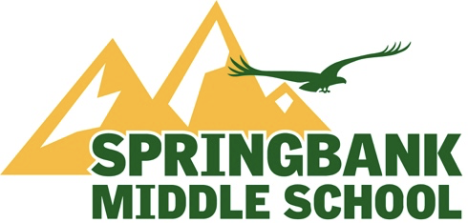

Springbank Middle School (SMS)
December School Council Meeting
1:00 P.M., Wednesday, December 6th, 2023

Zoom link:
Available on SMS Website

A G E N D A

- Welcome

  - Call Meeting to Order
  - Approval of Agenda
  - Approval of Meeting Minutes

- Trustee’s Report - Judi Hunter

- Administration Report - Glen Brooker & Stacey Poither

- Co-chair’s Report – Sandra Kachuik & Caley Remington

- Reports from Representative Positions

  - Band
  - Athletics Report
  - Canadian Parents for French
  - Fundraising
  - Fun Lunches
  - Spirit Day
  - Volunteer Coordinator
  - Grants
  - Learning Commons

6. Open Floor

7. Next Meetings
Jan 10 at 7 PM
Feb 7 at 1 PM
March 6 at 1 PM
April 3 at 1 PM
May 1 at 7 PM - AGM
June 5 at 1 PM

8. Adjournment

